|  |
| --- |
| [Type the company name] |
| Setting Up Firewall |
| Windows Server 2008 Standard – 32bit |

# Setting up Windows Firewall

* 1. Setting up Firewall to allow port “**8090**”
     1. Click on **Start >> Control Panel**

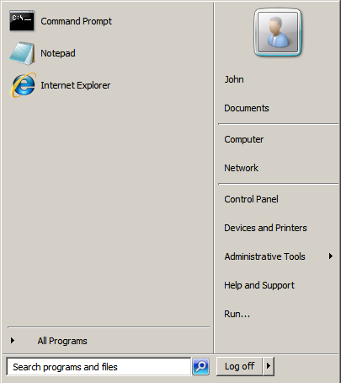

Figure 1: Start Menu

* + 1. Click on “**Classic View**” and then
    2. Click on “**Windows Firewall**”

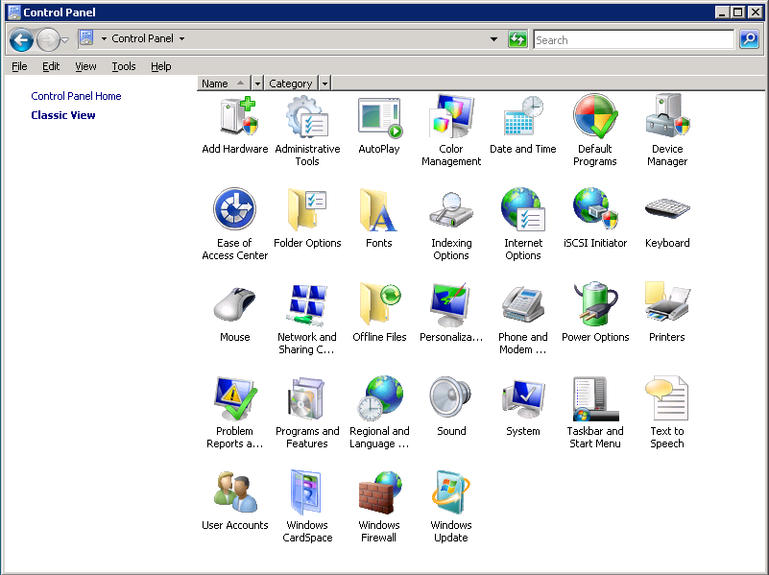

Figure 2: Control Panel

* + 1. Click on “**Allow a program through Windows Firewall**”

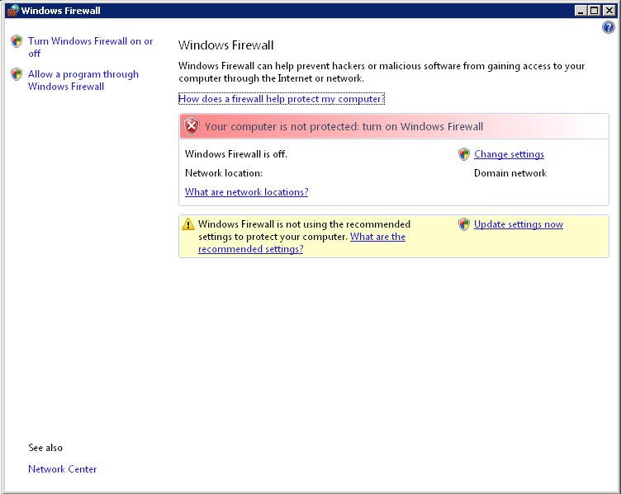

Figure 3: Advanced Settings

* + 1. Click on “**Continue**”

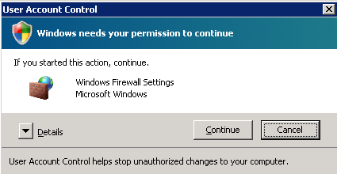

Figure 4: user Account Control

* + 1. Click on “Add Port”

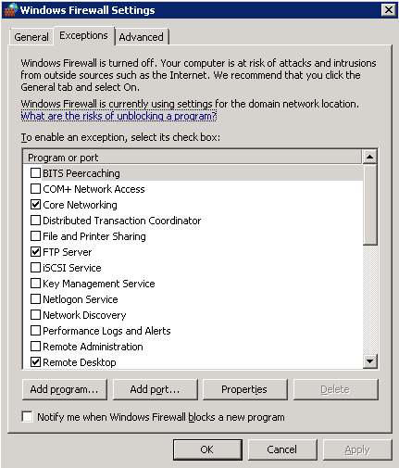

Figure : Windows Firewall Settings

* + 1. Enter Name : “**Accounting Plus Port**”
    2. Enter Port Number : “**8090**”
    3. Select Protocol as “**TCP**”
    4. Click “**OK**” to close the dialog.

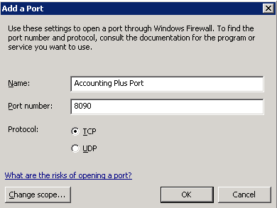

Figure : Add a port